|  |  |
| --- | --- |
| **Canon Selphy CP1300 Photo Printer**Máy In Ảnh Canon Selphy CP1300 (Black)  canon-selphy-cp1300-8 canon-selphy-cp1300-5 canon-selphy-cp1300-6 canon-selphy-cp1300-7 | **Featured information**   * Party Shuffle Print mode, USB Host port * Wireless printing support AirPrint and Mopria Print Service * Maximum resolution of 300 dpi * Apple AirPrint & Canon PRINT mobile app support   **Price: 200$**  **Specifications:**   * **Details:** The Canon Selphy CP1300 is a compact photo printer with a resolution of up to 300 dpi, printing photos from 2.1 x 2.1 inches to 4 x 6 inches. Possesses an optional battery, capable of printing 54 copies per charge. The device supports AirPrint connection and Canon PRINT Mobile App allows printing from the phone. Along with that is the 3.2-inch LCD screen design that can be folded up and down extremely conveniently. |

**Description:**

#### **Canon Selphy CP1300 Photo Printer**

The portable, compact, convenient Canon Selphy CP1300 photo printer allows users to easily create vivid and sharp photos with a resolution of up to 300 dpi. You can print photos from 2.1 x 2.1 inches to 4 x 6 inches quickly. In addition, with a completely new 2 x 6 inch layout feature, users have a variety of possibilities to choose and create their own printing styles.

#### **Stylish Design**

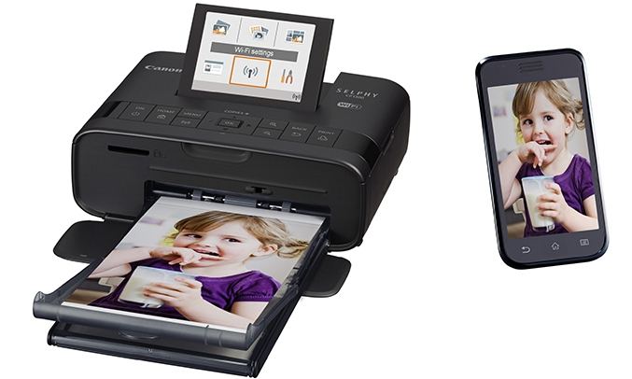

The color quality of the image on this Canon accessory is also extremely durable, thanks to the special protective film on the photos that protects the color and lasts up to 100 years. In addition to traditional glossy paper, printed photos are composed of 3 other materials: matte finishing materials, smooth finishing materials, and mesh. Not stopping there, the optional battery can print 54 copies of photos per charge, helping to enjoy many different frames.